**DESIGN AND IMPLEMENTATION OF ONLINE SCHOOL REGISTRATION AND FEES PAYMENT PORTAL**

**(A case study of Destiny Nursery and Primary School, EYN Hildi)**

**BY**

**ADI MNENGE RICHARD**

**(ST/CS/HND/23/017)**

**BEING A PROJECT PROPOSAL SUBMITTED TO THE DEPARTMENT OF COMPUTER SCIENCE, SCHOOL OF SCIENCE AND TECHNOLOGY, FEDERAL POLYTECHNIC, MUBI, ADAMAWA STATE. IN PARTIAL FULFILMENT OF THE REQUIREMENTS FOR THE AWARD OF HIGHER NATIONAL DIPLOMA (HND) IN COMPUTER SCIENCE.**

**PROJECT SUPERVISOR: MALLAM MUSTAPHA KASSIM**

**MARCH, 2025**

# CHAPTER ONE

# INTRODUCTION

## 1.1 Background to the Study

Education plays a vital role in the development of any nation. In recent years, there has been a significant shift towards the integration of technology in the education sector. One area where technology has made a significant impact is the payment of school fees. Traditional methods of school fee payment, such as cash or cheques, can be time-consuming, inefficient, and prone to errors. Online school fee payment systems have emerged as a viable solution, offering convenience, efficiency, and enhanced security. Online school fee payment systems offer several advantages over traditional payment methods. They provide a convenient platform for parents or guardians to make fee payments from anywhere at any time, eliminating the need for physical visits to the school. These systems also reduce the administrative burden on school staff by automating payment processing, record-keeping, and fee reconciliation. Furthermore, online payment systems enhance transparency and accountability, as both the school and parents can track payment transactions and generate digital receipts.

According to a recent study by Balogun and Adetokunboh (2021), the adoption of online payment systems in educational institutions has gained momentum due to the increasing reliance on technology and the need for streamlined administrative processes. The study emphasized that online fee payment systems eliminate the need for parents or guardians to physically visit the school to make payments, reducing the associated inconveniences and time-consuming tasks. Furthermore, online payment systems offer secure transaction channels, reducing the risks associated with handling cash and minimizing the chances of misplacing payment records.

Online payment is a paperless monetary transaction conducted over internet where electronic money is debited from buyer’s account and then transfer into Sellers’s account for exchange of goods or services. Glory and Jibril (2024), defined online payment system broadly “as the means and processes involved in conducting transactions online; however, this description can be expanded to include the online monetary connections between sellers, buyers, financial institutions, and intermediaries”. This definition implies that online payment system is associated with five major actors, namely, buyer, buyer’s bank, seller, seller’s bank and intermediary. The intermediary is a third party responsible for debiting money from customer’s account and crediting merchant’s account. The debiting, transferring and payment process is done in real-time by third party interface between the two banks. Third parties are also referred to as e-payment gateways. Nira Academy (2017) describe payment gateway as a software application that payment service providers use to process payments for online purchases, originating on a merchant’s website. It acts as an interface between the merchant’s website and a payment- processing bank, known as an acquirer. There are numerous types of third-party payment processing agencies (e-payment gateways). This includes Net Bank, PayPal, Google Wallet, Amazon Payment, Authorize.Net, Wechat Wallet, Stripe, WorldPay, and AliPay among others. Nigerian e-payment gateways on the other hand include Interswitch, Voguepay, Paystack, GTpay, SimplePay, PayU, E-Transact, Paga, GlobalPay and Remita among others. These online payment gateways are trustworthy, effective, efficient and reliable.

In addition to the benefits for parents and guardians, online payment systems also offer advantages to educational institutions. Kao and Li (2020), highlighted that online payment systems can enhance administrative efficiency by automating fee collection processes, reducing paperwork, and improving record-keeping. By integrating the online payment system with existing school databases, schools can streamline financial management, generate accurate reports, and facilitate easier reconciliation of payments. Several studies have highlighted the benefits of online school fee payment systems in educational institutions. A study by Thakur and Kotecha (2020), examined the impact of online fee payment systems on the efficiency and transparency of fee collection processes in Indian schools. The findings revealed that the implementation of online payment systems significantly reduced the time and effort required for fee management, improved financial reporting accuracy, and enhanced parent-school communication.

Devi and Rani (2021), investigated the challenges faced by parents and schools in the manual fee payment process and explored the advantages of online payment systems. The study emphasized that online payment systems can enhance data security, reduce cash handling risks, and improve overall financial management in schools. In the context of Nigeria, where Destiny Nursery and Primary School is located, the adoption of online registration and fees payment systems in educational institutions is still in its early stages. However, there is a growing recognition of the need to modernize fee collection processes and leverage technology for improved efficiency. A case study by Adamu *et al.* (2021), examined the implementation of an online fee payment system in a Nigerian university and highlighted the positive impact on fee collection, reduction of fraud cases, and enhanced financial transparency. However, despite the growing trend towards online payment systems, many educational institutions, including Destiny Nursery and Primary School, still rely on manual fee collection methods. This reliance on manual systems often leads to challenges such as delays in fee processing, errors in recording payments, and increased administrative workload.

## 1.2 Problem Statement

Despite the numerous benefits associated with online school fee payment systems, many educational institutions, including Destiny Nursery and Primary School, still rely on manual and traditional methods for fee collection. This reliance on manual systems often leads to challenges such as delays in fee processing, misplacement of payment records, and the inconvenience of parents physically visiting the school to make payments. Therefore, there is a need to design and implement an online registration and school fee payment system to address these challenges and improve the overall registration and fee payment process at Destiny Nursery and Primary School.

The problem statement for the design and implementation of the online school fee payment system for Destiny Nursery and Primary School can be summarized as follows:

1. The reliance on manual and traditional fee payment methods leads to inefficiencies in the fee collection process, including delays in fee processing and errors in recording payments.
2. The current fee payment system lacks a convenient and secure online platform, requiring parents and guardians to physically visit the school to make payments, causing inconvenience and consuming valuable time.
3. The absence of an integrated online payment system results in challenges in financial management and record-keeping, making it difficult to generate accurate reports and reconcile payments.
4. The existing fee payment methods do not provide adequate security measures, leaving room for potential risks, such as loss of payment records and unauthorized access to sensitive financial information.

## 1.3 Aim and Objectives

The aim of this project is to design and implement an online registration and school fee payment portal for Destiny Nursery and Primary School. The specific objectives are as follows:

1. To review the current existing system.
2. To identify the requirements and functionalities of an online school fee payment system.
3. To develop a user-friendly and secure online platform for fee payment.
4. To integrate the online payment system with existing school databases for seamless record-keeping.
5. To evaluate the effectiveness and user satisfaction of the implemented system.

## 1.4 Significance of the Study

The findings of this study will be beneficial to Destiny Nursery and Primary School and other educational institutions that are yet to adopt online school fee payment systems. The study will provide insights into the design and implementation of an efficient and secure payment system that can streamline fee collection processes, reduce administrative burdens, and enhance parent-school communication. Additionally, the study will contribute to the existing literature on online payment systems in educational settings.

## 1.5 Scope of the Study

The scope of this study encompasses the design and implementation of an online school fee payment system specifically tailored for Destiny Nursery and Primary School. The study will focus on the following areas; Development of an Online Payment Platform, Integration with Existing School Databases, and Security. Also, the study will focus on providing a positive user experience for parents and guardians. The online payment system will be designed to be intuitive, responsive, and accessible from various devices. Additionally, the system will incorporate features to facilitate effective communication between the school and parents, such as automated payment notifications and online receipt generation.

## 1.6 Definition of Some Operational Terms

**Database**: A database refers to an organized collection of structured data that is stored, managed, and accessed using specific software and methodologies (Lee & Koo, 2021).

**Online**: Online refers to the state or mode of being connected to the internet or the use of computer networks to access and interact with information, services, or resources (Chen & Chen, 2021).

**Payment**: It involves the settlement of financial transactions between parties and can be conducted using various methods such as cash, checks, credit/debit cards, and electronic transfers (Sutanto et al., 2020).

**Portal**: A portal refers to a web-based platform or gateway that provides access to various resources, information, and services (Li et al., 2020).

**School Fees**: School fees refer to the financial charges or expenses that parents or guardians are required to pay to educational institutions for the provision of academic programs, facilities, and services (Alcott & Rose, 2021).

**System**: A system refers to a collection of interconnected components, processes, or elements that work together to achieve a specific purpose or objective (Huang, 2021).

# CHAPTER TWO

# LITERATURE REVIEW

## 2.1 Introduction

This chapter presents a comprehensive literature review on online school fee payment systems, highlighting their benefits, challenges, and best practices. The review aims to provide a theoretical foundation and insights into the design and implementation of an effective online payment system for educational institutions, with a specific focus on Destiny Nursery and Primary School.

## 2.2 Online Payment System

The concept of payment existed for several centuries. Saxena (2023) defined payment in commercial context as “any exchange of value between two parties, where usually Party A offers a form of currency in exchange for a good or service provided by Party B”. Payment is heart of any commercial activity. Payment system according to Nedozi and Omoregie (2019) can be viewed as an arrangement consisting of institutions, instruments, organizations, operating procedures, and information and communication systems, usually within a nation’s financial system, used to initiate and transmit payment information from payer to payee and to settle payment or discharge financial obligation among economic units. Payment system can be physical of electronic. Physical payment system in commercial context involves customer paying cash directly to merchant in exchange of goods. Physical payment system is the traditional method of payment and proved to be effective. However, it requires the presence of the customer, merchant and paper money for transaction to take place. In this sense, physical payment system could be stressful, time consuming and costly in terms of the cost of printing paper money as well as the papers use in transaction. It is also risky as the customer carry cash to merchant for transaction. It is for these reasons and more that electronic payment (e-payment) and online payment systems were introduced.

Online payment system is a type of payment in which business transaction take place on internet between business to customer (B2C) or business to business (B2B). For online payment system to be effective and complete, it requires a third party (Payment gateway) who will debit customer’s account and later credit merchant’s account. The process of online payment is shown in Figure 2.1.

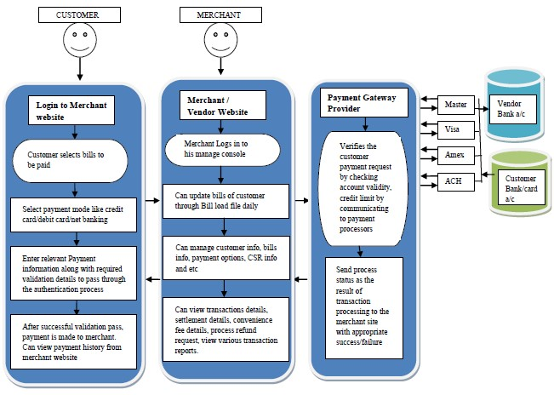

Figure 2.1: Online Payment System Adapted (Nagasubramanian & Rajagopalan, 2022)

## 2.3 Benefits of Online School Fee Payment Systems

Online payment systems have advantages as well as disadvantages. Yang (2017) stated that online payment systems are more convenient, fast, efficient and economical when compared with the traditional payment system. Ogedebe and Babatunde (2022), posited that e-payment or online payment eliminate opportunity for corruptive tendencies and improve quality of reporting system in the Nigerian public sector. However, despite the advantages of e-payment and online payment systems, they are not effective and efficient in Nigeria due to numerous challenges facing their operators. Such challenges according to Ogedebe and Babatunde (2022) include, lack of uniform platform by Banks and MDAs, lack of adequate infrastructures, lack of seriousness by Banks, resistance to changes in technology among customers and staff and security in terms of platform, hackers and virus attacks. However, Government and private sector are making concerted efforts in addressing these challenges. Such efforts have yielded positive results as volume of e-payment and online payment is witnessing exponential growth. E-payment and online payment are now ubiquitous in Nigeria. Online payment system is now use as part of electronic banking system, electronic commerce (e-commerce), online shopping payment and as a platform for payment of school fees in Universities and Colleges.

Development of online platforms for payment of school fees in Universities, Colleges and Schools in Nigeria and around the world in general is receiving greater attention in the past three decades. Computer Scientists have developed a number of e-payment or online payment systems for students’ school fees payment and other related matters in Universities, Colleges and Schools. For example, Ele and Obono (2018), developed an enhanced e-payment system that enables students of the University of Calabar, as well as their sponsors to securely pay fees online using valid credit and debit cards. Lwanga (2024) developed online fees payment system for Makerere University. Rachitha *et al.* (2018) developed an Android-based college fees payment application. These fees payment platforms remove delays and stress associated with manual systems of school fees payment. Online school fee payment systems have gained significant attention in recent years as educational institutions seek to leverage technology to streamline administrative processes and enhance parent-school interactions. These systems provide a digital platform for parents or guardians to conveniently and securely make fee payments online. Online school fee payment systems offer numerous advantages over traditional payment methods.

Research by Balogun and Adetokunboh (2021) emphasizes that these systems enhance convenience for parents and guardians by eliminating the need to physically visit the school for fee payments. Online payments allow for 24/7 accessibility, enabling users to make payments at their convenience, reducing time and effort.

Furthermore, online payment systems enhance administrative efficiency. Kao and Li (2020) note that these systems automate fee collection processes, reducing paperwork and administrative burden. By integrating with school databases, accurate and real-time payment records can be generated, simplifying financial management and reconciliation of payments.

Security is a critical aspect of online payment systems. Wahyudi *et al*. (2021) stress the importance of implementing robust security measures to protect sensitive financial information and prevent unauthorized access. Encryption protocols, secure payment gateways, and user authentication mechanisms are key components in ensuring the security and integrity of online transactions.

## 2.3.1 Convenience and Accessibility

Online payment systems offer convenience by eliminating the need for parents or guardians to physically visit the school to make payments. Users can access the system at anytime from anywhere with internet connectivity, providing flexibility and ease of use (Balogun & Adetokunboh, 2021). This convenience saves time and effort for both parents and school staff.

## 2.3.2 Administrative Efficiency

Online payment systems automate and streamline the fee collection process, reducing administrative workload and paperwork. The integration of these systems with school databases enables accurate record-keeping, easy tracking of payments, and efficient generation of financial reports (Kao & Li, 2020). Administrative staff can focus on higher-value tasks, improving overall operational efficiency.

## 2.3.3 Enhanced Security

Implementing robust security measures is crucial in online payment systems to protect sensitive financial information and prevent unauthorized access. Secure payment gateways, encryption protocols, and user authentication mechanisms ensure the confidentiality and integrity of transactions (Wahyudi et al., 2021). These security features instill trust in users and protect against potential risks.

## 2.3 Challenges and Considerations

Despite the benefits, online school fee payment systems also present challenges that need to be addressed. One challenge is the digital divide and accessibility. According to Jelena and Zoran (2020), disparities in internet access and technological infrastructure may hinder the adoption and usage of online payment systems, especially in certain regions or communities.

User acceptance and trust are crucial for the success of online payment systems. Sutanto, Palme, and Chua (2020) highlight the importance of addressing perceived risks and concerns related to security, privacy, and reliability. Building user confidence through transparent security measures and effective communication is essential.

Integration with existing school systems is a critical consideration. Lee and Koo (2021) emphasize the need for database integration to ensure seamless data exchange and synchronization between the online payment system and other school management systems. This integration facilitates efficient record-keeping, report generation, and data analysis.

Several best practices can guide the design and implementation of an effective online school fee payment system. A user-centered design approach is crucial for creating a user-friendly interface. Huang and Lu (2020) suggest involving parents, guardians, and school stakeholders in the design process to ensure the system meets their needs and preferences.

Usability testing and continuous improvement are vital. Yusoff and Mohamad (2021) emphasize the importance of iterative testing and user feedback to identify and address usability issues, ensuring a smooth and intuitive user experience.

Communication and support channels play a significant role. Clear and timely communication regarding the availability, benefits, and usage of the online payment system is essential for user adoption. Providing multiple support channels, such as helplines or FAQs, assists users in resolving any issues or concerns they may encounter.

## 2.4 Information Management System

An information management system (IMS) is a comprehensive framework that encompasses the processes, technologies, and strategies used to collect, organize, store, retrieve, and analyze information within an organization. An information management system refers to the integrated set of processes, tools, and technologies that enable organizations to effectively manage their information assets. It includes various components such as data collection, storage, retrieval, analysis, and dissemination (Khumalo, 2020).

## 2.4.1 Importance of Information Management Systems

1. Decision Making and Strategic Planning IMS enables organizations to gather and analyze relevant data, providing valuable insights that support informed decision-making and strategic planning (Delen, 2021). By providing accurate and up-to-date information, IMS enhances the ability of managers to make informed decisions in a timely manner.
2. Improved Efficiency and Productivity Efficient information management improves operational efficiency and productivity. By centralizing information, eliminating duplication, and automating processes, IMS streamlines workflows, reduces manual effort, and enhances overall efficiency (Wang, Liu, & Lee, 2021).
3. Enhanced Collaboration and Knowledge Sharing IMS facilitates effective collaboration and knowledge sharing within organizations. It provides a centralized platform for employees to access and share information, fostering collaboration, and enabling knowledge transfer (Al-Khouri & Abu-Jarour, 2020).

## 2.5 Database Management System

Database Management Systems (DBMS) are essential tools for storing, organizing, managing, and retrieving data efficiently. DBMS provide a structured approach to store and retrieve data, ensuring data integrity, security, and scalability for organizations.

Recent studies have highlighted the significance of DBMS in various domains. A research article by Ramakrishnan and Gehrke (2020), emphasized that DBMS are crucial for managing the increasing volumes of data generated in today's digital world. The study highlighted that DBMS enable organizations to handle diverse data types, ensure data consistency, and support complex data queries.

One of the key functions of DBMS is data storage and organization. DBMS provide a structured framework for storing data in tables, defining relationships between tables, and enforcing data integrity through constraints. These systems often employ relational models, such as the widely-used SQL (Structured Query Language), to manage data in a tabular format. A study by Elmasri and Navathe (2019), emphasized that DBMS enable efficient data storage, normalization, and indexing to optimize data retrieval performance.

Moreover, DBMS offer tools for data retrieval and manipulation. These systems allow users to query the database using SQL or other query languages to retrieve specific data based on specified criteria. DBMS also support complex operations such as joining multiple tables, filtering data, and aggregating results. A research article by Rizvi et al. (2021) highlighted the role of DBMS in enabling efficient and accurate data retrieval, facilitating decision-making and analysis.

DBMS also provide mechanisms for data security and access control. These systems enable organizations to define user roles and permissions, ensuring that only authorized users can access and modify the data. DBMS also offer features such as data encryption, backup, and recovery to protect against data breaches and system failures. A study by Motahari-Nezhad et al. (2021) emphasized the importance of DBMS in ensuring data privacy, integrity, and availability, particularly in the context of sensitive and regulated data.

The advent of advanced technologies has further enhanced the capabilities of DBMS. Distributed DBMS enable data storage and processing across multiple servers, providing scalability, fault tolerance, and high availability. NoSQL (Not Only SQL) DBMS have emerged as alternatives to traditional relational DBMS, offering flexible data models and scalability for handling large volumes of unstructured and semi-structured data. A research article by Ghazal *et al.* (2020), discussed the benefits and challenges of NoSQL DBMS in big data environments.

## 2.6 Related studies

Adebayo and Salihu (2020) examined the adoption of online registration systems in Nigerian universities, identifying key challenges such as internet accessibility, poor ICT infrastructure, and technical difficulties faced by students and administrators. Their findings suggest that while online systems improve efficiency, inadequate training and lack of awareness hinder smooth adoption. They further highlighted that many institutions lack sufficient funding to maintain or upgrade these systems, leading to frequent downtimes during peak registration periods. Additionally, their study pointed out the reluctance of some academic staff to transition fully to digital platforms due to a preference for traditional methods. To address these issues, Adebayo and Salihu recommended targeted ICT training programs for students and staff, as well as increased government and private sector investment in technological infrastructure. They also proposed that institutions should establish dedicated support centers to assist students during registration. By implementing these strategies, they argued that universities could enhance the effectiveness of online registration systems, leading to a more streamlined and user-friendly experience.

Similarly, Alade and Adeyemi (2021) studied the effectiveness of e-payment systems for tuition transactions in Nigerian tertiary institutions. Their research revealed that digital payment platforms streamline the fee payment process, reduce administrative burdens, and minimize cash handling risks, although security concerns and transaction failures remain issues. They found that most students and parents preferred online payment due to its convenience and time efficiency. However, inconsistent transaction confirmations and unexpected payment failures were commonly reported, causing frustration among users. To mitigate these challenges, the authors suggested that schools should partner with reliable payment service providers that offer real-time transaction verification. They also emphasized the need for periodic system audits to ensure proper functionality and security. Moreover, Alade and Adeyemi advocated for the implementation of multiple payment options, such as bank transfers, mobile money, and card payments, to accommodate diverse user preferences and enhance accessibility.

Chen and Zhang (2019) evaluated the impact of online student registration systems on administrative efficiency. Their study demonstrated that institutions using automated systems experienced a significant reduction in paperwork and manual errors, leading to faster processing times and improved student satisfaction. Additionally, they noted that online registration allows for better data tracking and management, helping universities monitor student enrollment trends more accurately. Despite these advantages, they found that some institutions faced initial resistance from both students and staff, primarily due to concerns over system reliability and user-friendliness. The study recommended that institutions invest in system usability testing and provide clear user guidelines to ease the transition. Furthermore, they suggested integrating artificial intelligence-driven support chatbots to assist students with common registration issues, reducing the need for human intervention. By addressing these concerns, Chen and Zhang concluded that universities could fully maximize the benefits of online registration systems.

Davidson and McCarthy (2020) analyzed security challenges in online school fee payment systems in the United States. They found that cybersecurity threats such as data breaches, phishing attacks, and unauthorized access pose serious risks, emphasizing the need for encryption, multi-factor authentication, and periodic system audits. Their research indicated that cybercriminals often target educational institutions due to their vast repositories of sensitive financial and personal data, making security a top priority for school administrators. To enhance security, Davidson and McCarthy suggested implementing robust firewall protections and continuous security monitoring. They also recommended regular cybersecurity training for students and staff to raise awareness about potential threats and best practices for safeguarding their accounts. Additionally, their study highlighted the importance of schools collaborating with cybersecurity firms to perform routine vulnerability assessments and strengthen their online payment systems against evolving threats.

Eze and Okoro (2022) explored how online registration portals enhance student experience in African universities. Their findings indicate that web-based registration improves accessibility, reduces long queues, and allows students to complete enrollment from remote locations. They found that students in rural areas, however, faced difficulties accessing online portals due to unstable internet connectivity. Moreover, some universities lacked adequate technical support to address system failures, which occasionally resulted in registration delays. To address these issues, Eze and Okoro recommended that institutions develop offline registration alternatives that automatically sync once an internet connection is restored. They also emphasized the importance of integrating mobile-friendly registration platforms to accommodate students who rely on smartphones for internet access. Additionally, they suggested that governments and educational bodies invest in broadband expansion initiatives to improve connectivity in underserved areas.

Garcia and Torres (2021) investigated the role of financial technology (fintech) in modernizing school fee payment systems. Their research highlighted that fintech companies like PayPal, Stripe, and Flutterwave have revolutionized tuition payment by offering secure, fast, and user-friendly transaction solutions. Their findings indicated that fintech-powered payment systems reduced processing time and minimized human errors in financial transactions. However, they also noted that transaction fees associated with some platforms posed financial burdens on students and parents. To counter these drawbacks, Garcia and Torres proposed that educational institutions negotiate lower transaction fees with fintech service providers or explore cost-effective alternatives. They also recommended the adoption of blockchain technology to enhance transparency and security in payment processing. By leveraging fintech solutions effectively, they concluded that schools could significantly enhance the efficiency and reliability of their fee payment systems.

Hassan and Ahmed (2018) conducted a comparative study on manual and automated school registration systems in Asia. Their research confirmed that digital registration processes eliminate paperwork-related delays, ensure accuracy, and enhance data management, though technical issues occasionally cause system downtime. They found that while digital registration improved efficiency, some students struggled with navigating the platforms due to poor system design and lack of training. The authors suggested that schools prioritize user experience by conducting regular feedback surveys and refining system interfaces based on student and staff input. They also emphasized the need for IT support teams to be readily available during peak registration periods to resolve technical difficulties. By making these improvements, they argued, institutions could optimize their digital registration systems for better performance.

James and Williams (2020) examined the long-term impact of online registration systems on student enrollment. Their longitudinal study revealed that institutions with fully integrated digital enrollment platforms witnessed increased student registration rates and improved record-keeping efficiency. They found that online registration attracted more distance-learning students who preferred digital enrollment over physical visits to campus offices. However, they also noted that schools with weak system infrastructures experienced frequent downtimes, leading to dissatisfaction among students. To enhance performance, they recommended that institutions invest in cloud-based solutions that offer greater scalability and stability. Additionally, they advised universities to integrate data analytics tools to monitor student enrollment trends and predict future registration needs. These improvements, they argued, would help schools manage their enrollment processes more effectively.

Kumar and Rao (2021) explored the efficiency of blockchain technology in school fee payment systems. Their study demonstrated that blockchain enhances transaction transparency, prevents fraud, and ensures secure payment processing, although the high cost of implementation remains a limitation. They found that blockchain technology reduces dependency on third-party intermediaries, thereby lowering transaction costs over time. Despite its benefits, the authors cautioned that blockchain adoption requires significant technical expertise and investment. They recommended that institutions collaborate with fintech companies to develop hybrid models that combine blockchain's security with traditional payment platforms' ease of use.

## 2.7 Summary of Literatures

This chapter presented a comprehensive literature review on online school fee payment systems. The review highlighted the benefits of online payment systems, including convenience for parents, administrative efficiency, and enhanced security. Challenges such as the digital divide, user acceptance, and system integration were discussed. Best practices and recommendations were provided to guide the design and implementation of an effective online payment system.

# CHAPTER THREE

# SYSTEM ANALYSIS AND DESIGN

## 3.1 Introduction

This chapter contains the system design and analysis of the proposed system, the disadvantages of the existing system in Destiny Nursery and Primary School, Hildi, the advantages of the proposed system over the existing system, the requirements (Hardware and Software), the design and the system architecture.

## 3.2 Disadvantages of the existing system

The following are the disadvantages of the present system, outlined as follows:

1. The existing system likely involves a lot of manual work, such as filling out paper forms, handling cash or cheques, and maintaining physical records.
2. Parents and guardians may have to visit the school premises physically to make fee payments.
3. The existing system might only accept a few payment methods, such as cash or cheques.
4. The manual processing of fees can be time-consuming for school administrators and staff, diverting their focus from other critical tasks.
5. The existing system may not be integrated with other school management systems, leading to duplication of efforts and data discrepancies.

## 3.3 Advantages of the proposed system

The proposed Online School Fee Payment System for Destiny Nursery and Primary School, Hildi, offers numerous advantages over the existing manual system. Here are some of the key advantages:

1. Convenience for Parents and Guardians: Parents and guardians can make fee payments from the comfort of their homes or offices, eliminating the need to visit the school premises physically.
2. 24/7 Accessibility: The online system allows parents to access the fee payment platform at any time, making it convenient for them to pay fees, view payment history, and download receipts at their convenience.
3. Multiple Payment Options: The system will support various payment methods, including credit/debit cards, online banking, and mobile wallets, providing flexibility to parents in choosing their preferred payment mode.
4. Secure Payment Processing: Integration with a reliable and secure payment gateway will ensure safe and encrypted transactions, minimizing the risk of fraud and ensuring the confidentiality of payment details.
5. Improved Data Accuracy: With automated processes and centralized data storage, the system will reduce the chances of errors in fee calculation and maintain accurate payment records.
6. Easy Fee Reconciliation: The system will make it easier for school administrators to reconcile fee payments with student records, reducing manual effort and the likelihood of discrepancies.
7. Integration with School Management System: The online fee payment system can be integrated with the existing school management system, streamlining administrative processes and ensuring consistent and up-to-date data across systems.

## 3.4 Software Development Model

The waterfall model is a traditional sequential approach to software development that consists of distinct phases that follow a linear sequence. Here is a simplified version of the waterfall model for the development of an Online School Fee Payment System for Destiny Nursery and Primary School, Hildi:

**Requirements Gathering and Analysis:**

1. Identify the requirements and objectives of the Online Fee Payment system.
2. Conduct interviews and discussions with stakeholders to understand their needs.
3. Define the system's functionalities, user roles, and security requirements.

**System Design:**

1. Design the system architecture, including the client-side and server-side components.
2. Create the database schema and define the data model.
3. Develop the user interface design, considering usability and accessibility.

**Implementation:**

1. Develop the client-side application using web technologies like HTML, CSS, and JavaScript.
2. Implement the server-side application using a suitable programming language and framework.
3. Integrate the user interface with the backend functionalities.
4. Implement security measures such as encryption, authentication protocols, and access control.

**Testing:**

1. Conduct unit testing to verify the correctness of individual components.
2. Perform integration testing to ensure the proper functioning of the system as a whole.
3. Carry out system testing to validate the system against the defined requirements.
4. Perform security testing to identify and address any vulnerabilities.

**Deployment:**

1. Prepare the system for deployment by configuring the necessary infrastructure and servers.
2. Install and set up the required software and dependencies.
3. Migrate the database and ensure data integrity.
4. Conduct user acceptance testing to gain feedback and ensure readiness for production use.

**Maintenance and Support:**

1. Provide ongoing maintenance and support for the Online Fee Payment system.
2. Address any reported issues, bugs, or security vulnerabilities.
3. Perform regular system updates and enhancements based on user feedback and changing requirements.
4. Ensure the system remains secure, reliable, and up-to-date.

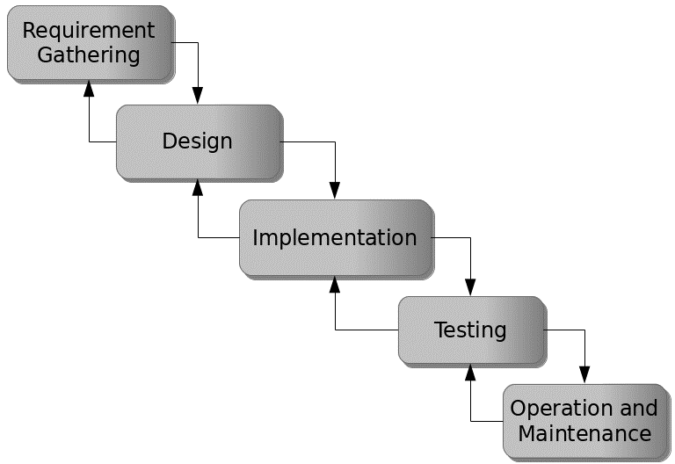

Figure 3.1: Waterfall model

## 3.5 Method of Data Collection

This study will adopt two methods of data collection:

**Primary Source:** Primary source refers to the sources of collecting original data in which the researcher makes use of empirical approach such as personal interview, questionnaires or observation.

**Secondary Source:** The need for the secondary sources of data for this kind of project cannot be over emphasized. The secondary data were obtained from magazines, Journal, newspapers, library source and most of the information from the library research has been covered in the literature review section.

## 3.6 System Design

Systems design is the process of defining the architecture, modules, interfaces, and data for a system to satisfy specified requirements. Systems design could be seen as the application of systems theory to product development.

## 3.6.1 Algorithm Diagram

**Use case diagram**

A use case diagram at its simplest is a representation of a user’s interaction with the system and depicting the specifications of a use case.

Registration

Login

Update Profile

Pay School Fee

Confirm Payment

Admin

Student (Guardian)

Check Result

View Classmates

Update System information

Print Result

Print Receipt

Log out

Figure 3.2: Use case diagram

**3.6.2 System Architecture**

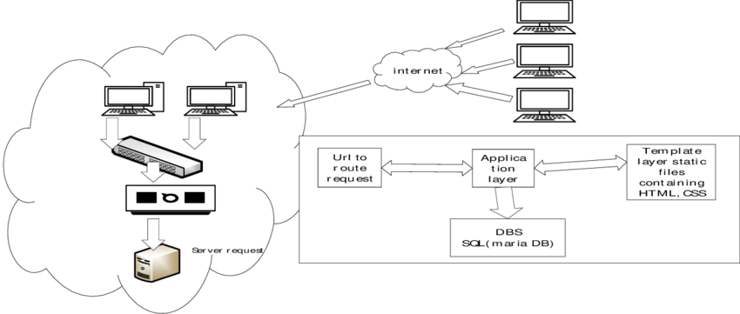

Figure 3.2: System Architecture

**3.6.3 Database Tables/Queries Structures**

## Table 3.1: Payment Table

|  |  |  |  |  |
| --- | --- | --- | --- | --- |
| **Field** | **Datatype (length)** | **Null** | **Key** | **Extra** |
| id | int(10) | NO | PRI | auto_increment |
| Student name | varchar(50) | YES |  |  |
| Student Email | varchar(50) | YES |  |  |
| Student Phone | varchar(50) | YES |  |  |
| Student Class | varchar(50) |  |  |  |
| Amount Paid | varchar(50) |  |  |  |
| Reference id | varchar(50) |  |  |  |
| Date | timestamp |  |  |  |

#### **Table 3.2: Classes Table**

|  |  |  |  |  |  |
| --- | --- | --- | --- | --- | --- |
| **Field** | **Type** | **Null** | **Key** | **Default** | **Extra** |
| id | int(10) | NO | PRI |  | auto_increment |
| classes | varchar(50) | YES |  |  |  |
| date_added | varchar(50) | YES |  |  |  |
| time_added | timestamp | YES |  | current_timestamp() |  |

#### **Table 3.3: Administratives Table**

|  |  |  |  |  |  |
| --- | --- | --- | --- | --- | --- |
| **Field** | **Type** | **Null** | **Key** | **Default** | **Extra** |
| id | int(10) | NO | PRI |  | auto_increment |
| school_name | varchar(255) | YES |  |  |  |
| school_motto | varchar(255) | YES |  |  |  |
| school_logo | varchar(255) | YES |  |  |  |
| school_stamp | varchar(255) | YES |  |  |  |
| upload_date | varchar(50) | YES |  |  |  |
| upload_time | timestamp | YES |  | current_timestamp() |  |

#### **Table 3.4: Current Session Table**

|  |  |  |  |  |  |
| --- | --- | --- | --- | --- | --- |
| **Field** | **Type** | **Null** | **Key** | **Default** | **Extra** |
| id | int(10) | NO | PRI |  | auto_increment |
| current_session | varchar(20) | YES |  |  |  |
| current_term | varchar(50) | YES |  |  |  |
| date_declared | varchar(50) | YES |  |  |  |
| time_declared | timestamp | YES |  | current_timestamp() |  |

#### **Table 3.5: Result Table**

|  |  |  |  |  |  |
| --- | --- | --- | --- | --- | --- |
| **Field** | **Type** | **Null** | **Key** | **Default** | **Extra** |
| id | int(10) | NO | PRI |  | auto_increment |
| class | varchar(10) | YES |  |  |  |
| term | varchar(50) | YES |  |  |  |
| session | varchar(50) | YES |  |  |  |
| reg_number | varchar(50) | YES |  |  |  |
| name | varchar(50) | YES |  |  |  |
| subjects | varchar(100) | YES |  |  |  |
| ca | int(10) | YES |  |  |  |
| project | int(10) | YES |  |  |  |
| exam | int(10) | YES |  |  |  |
| subject_total | int(10) | YES |  |  |  |
| subject_rank | int(10) | YES |  |  |  |
| date_of_upload | varchar(20) | YES |  |  |  |
| time_of_upload | timestamp | NO |  | current_timestamp() |  |

#### **Table 3.6: Subjects**

|  |  |  |  |  |  |
| --- | --- | --- | --- | --- | --- |
| **Field** | **Type** | **Null** | **Key** | **Default** | **Extra** |
| id | int(10) | NO | PRI |  | auto_increment |
| reg_number | varchar(100) | YES |  |  |  |
| name | varchar(100) | YES |  |  |  |
| class | varchar(20) | YES |  |  |  |
| subjects | varchar(100) | YES |  |  |  |
| term | varchar(50) | YES |  |  |  |
| session | varchar(50) | YES |  |  |  |
| registration_date | varchar(20) | YES |  |  |  |
| registration_time | timestamp | YES |  | current_timestamp() |  |

#### **Table 3.7: Students**

|  |  |  |  |  |  |
| --- | --- | --- | --- | --- | --- |
| **Field** | **Type** | **Null** | **Key** | **Default** | **Extra** |
| id | int(10) | NO | PRI |  | auto_increment |
| gender | varchar(20) | YES |  |  |  |
| firstname | varchar(50) | YES |  |  |  |
| lastname | varchar(50) | YES |  |  |  |
| othername | varchar(50) | YES |  |  |  |
| dob | varchar(50) | YES |  |  |  |
| mob | varchar(50) | YES |  |  |  |
| yob | varchar(50) | YES |  |  |  |
| contact_phone | varchar(20) | YES |  |  |  |
| address | text | YES |  |  |  |
| lga | varchar(255) | NO |  |  |  |
| state | varchar(50) | YES |  |  |  |
| nationality | varchar(50) | YES |  |  |  |
| sponsor_name | varchar(50) | YES |  |  |  |
| sponsor_phone | varchar(20) | YES |  |  |  |
| relationship | varchar(20) | YES |  |  |  |
| class | varchar(20) | YES |  |  |  |
| reg_number | varchar(100) | YES |  |  |  |
| gen_password | varchar(20) | YES |  |  |  |
| passport | varchar(255) | YES |  |  |  |
| date_of_reg | varchar(20) | YES |  |  |  |
| time_of_reg | timestamp | YES |  | current_timestamp() |  |

#### **Table 3.8: Teachers**

|  |  |  |  |  |  |
| --- | --- | --- | --- | --- | --- |
| **Field** | **Type** | **Null** | **Key** | **Default** | **Extra** |
| id | int(10) | NO | PRI |  | auto_increment |
| title | varchar(50) | YES |  |  |  |
| fullname | varchar(100) | YES |  |  |  |
| address | text | YES |  |  |  |
| phone | varchar(50) | YES |  |  |  |
| state | varchar(50) | YES |  |  |  |
| lga | text | YES |  |  |  |
| nationality | varchar(50) | YES |  |  |  |
| email | varchar(50) | YES |  |  |  |
| password | varchar(50) | YES |  |  |  |
| date_of_reg | varchar(50) | YES |  |  |  |
| time_of_reg | timestamp | YES |  | current_timestamp() |  |

#### **Table 3.9: Users**

|  |  |  |  |  |  |
| --- | --- | --- | --- | --- | --- |
| **Field** | **Type** | **Null** | **Key** | **Default** | **Extra** |
| id | int(10) | NO | PRI |  | auto_increment |
| title | varchar(50) | YES |  |  |  |
| fullname | varchar(100) | YES |  |  |  |
| address | text | YES |  |  |  |
| phone | varchar(50) | YES |  |  |  |
| state | varchar(50) | YES |  |  |  |
| lga | text | YES |  |  |  |
| nationality | varchar(50) | YES |  |  |  |
| email | varchar(50) | YES |  |  |  |
| password | varchar(50) | YES |  |  |  |
| date_of_reg | varchar(50) | YES |  |  |  |
| time_of_reg | timestamp | YES |  | current_timestamp() |  |

**3.6.4 Database Entity Relationship Diagram**

This shows the relationship of the various tables in the database with each other

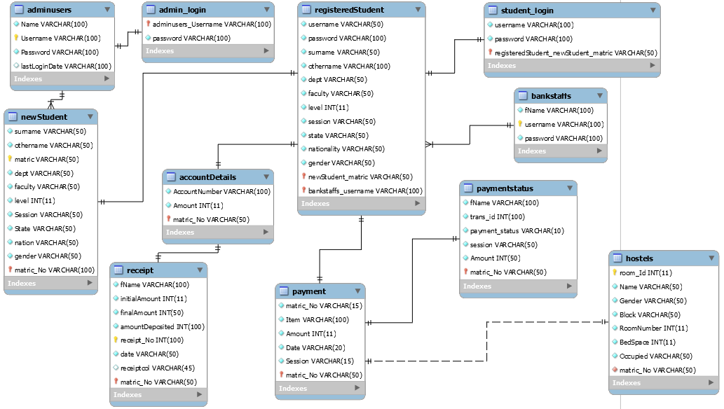

Figure 3.3: Database Entity Relationship Diagram

**3.6.5 The Input and Output Design**

Username or Registration Number

Enter Password

#### Don't Have an Account? [Create Account](http://localhost/school_dev/app.php#demanppopUpWindow)

Login

Figure 3.4: Login interface

CREATE PROFILE

Your Gender

User Type

First Name

Last Name

Phone Number

Email Address

Figure 3.5: Create Profile interface

**PAY WITH**

Card

Bank

Transfer

*# USSD

amir@yahoo.com

Pay **7,000.00**

Use the test bank account provided below to complete this payment

Zenith Bank

2203002930

**Verify Account**

Figure 3.6: Payment interface

Gender

First Name (Surname)

Last Name

Other Name (Optional)

Email

Phone Number

Home Address

State of Origin

LGA of Origin

Day

Month

Year

Sponsor Name

Phone Number

Target Class

Relationship

REGISTER

Figure 3.7: Complete Registration interface

**CONFIRM PAYMENT**

Reference code

Figure 3.8: Payment confirmation interface

## 3.7 System Requirement Specification

**3.7.1 Hardware Requirements**

The software designed needed the following hardware for an effective operation of the newly designed system.

1. A system running on intel, P(R) duo core with higher processor
2. The-Random Access Memory (RAM) should be at least 512mb.
3. Enhanced keyboard.
4. At least 20-GB hard disk.
5. V.G.A or a colored monitor.

**3.7.2 Software Requirements**

The software requirements include:

1. A window 7 or higher version of operating system.
2. XAMP or WAMP for Database
3. PHP

## 3.7.3 Personnel Requirements

Any computer literate who has a technical knowhow of internet surfing can use the system because it is user friendly.